**Pertemuan 4 : Java Script Part 2**

**Tugas 4 : Membuat PopUp Dan Event**

|  |  |
| --- | --- |
| **Nama / Nim** | **:Galih Rahmatdhani Perdana/2218107** |
| **Kelas** | **:G** |
| **Pengajar** | **:** **MOHAMMAD HARIFIN** |

* 1. **Tujuan**

1. Praktikan Mampu memahami dasar – dasar Javascript.
2. Praktikan Mampu memahami penggunaan Javascript.
3. Praktikan Mampu memahami DOM pada Javascript.
   1. **Alat dan Bahan**
4. Laptop/pc
5. Modul Praktikum Web 2024
6. TextEditor (Visual Studio Code / Sublime Text)
   1. **Langkah-langkah**
7. Index.html

Source code HTML:

|  |
| --- |
| <!DOCTYPE html>  <html lang="en">  <head>  <meta charset="UTF-8" />  <meta name="viewport" content="width=device-width, initial-scale=1.0" />  <title>KOPI KETENANGAN</title>  <link rel="stylesheet" href="css/style.css" />  </head>  <body>  <header id="navbar">  <div class="container" >  <img src="asset/logo.png" alt="logo" class="logo"/>  <nav>  <ul type="square">  <li><a href="#">Home</a></li>  <li><a href="RegisterKopiKetenangan.html">Register</a></li>  <li><a href="adminkopi.html">Admin</a></li>  <li><a href="adminkopi.html">Katalog</a></li>  <li><a href="adminkopi.html">Lokasi</a></li>  <li class="login"><a href="LoginKopiKetenangan.html">Login</a></li>  <li><a href="adminkopi.html">Lokasi</a></li>  </ul>  </nav>  </div>  </header>  <section class="News">  <div class="isi">  <h2>Grind The</2>  <h2>Essentials</h2>  <p>Dibuat dari biji kopi Indonesia pilihan untuk</p>  <p>pengalaman minum kopi terbaik setiap hari</p>  <a href="RegisterKopiKetenangan.html" class="btn">Get Started</a>  </div>  </section>  <section class="testimoni">  <div>  <img class="g1" src="asset/1.png" alt="">  <img class="g2" src="asset/2.png" alt="">  </div>  <h1>Product</h1>  <h2>Coba Produk Unggulan Kami Sekarang</h2>  <div class="carousel">  <button class="prev" onclick="prevSlide()">&#10094;</button>  <div class="carousel-inner">  <div class="carousel-item">  <img src="asset/produk/2.png" alt="Produk 1">  <div class="item-content">  <h3>Cappucino</h3>  <p>Harga: $10</p>  <button id="popupBtn" onclick="beli()" value="Cappucino">Beli Sekarang</button>  </div>  </div>  <div class="carousel-item">  <img src="asset/produk/1.png" alt="Produk 2">  <div class="item-content">  <h3>Caffe Latte</h3>  <p>Harga: $15</p>  <button id="popupBtn" onclick="beli()" value="Caffe Latte">Beli Sekarang</button>  </div>  </div>  <div class="carousel-item">  <img src="asset/produk/3.png" alt="Produk 3">  <div class="item-content">  <h3>Tubruk</h3>  <p>Harga: $20</p>  <button id="popupBtn" onclick="beli()" value="Tubruk">Beli Sekarang</button>  </div>  </div>  <div class="carousel-item">  <img src="asset/produk/4.png" alt="Produk 3">  <div class="item-content">  <h3>Kopi Susu</h3>  <p>Harga: $20</p>  <button id="popupBtn" onclick="beli()" value="Kopi Susu">Beli Sekarang</button>  </div>  </div>  <div class="carousel-item">  <img src="asset/produk/5.png" alt="Produk 3">  <div class="item-content">  <h3>Expreso</h3>  <p>Harga: $20</p>  <button id="popupBtn" onclick="beli()" value="Expreso">Beli Sekarang</button>  </div>  </div>  </div>  <button class="next" onclick="nextSlide()">&#10095;</button>  </div>  <div id="popup" class="popup">  <h4 id="judul"></h4>  <form id="purchaseForm">  <label for="quantity">Jumlah:</label>  <input type="number" id="quantity" name="quantity" min="1" required>  <label for="paymentMethod">Metode Pembayaran:</label>  <select id="paymentMethod" name="paymentMethod" required>  <option value="">Pilih metode pembayaran</option>  <option value="CreditCard">Kartu Kredit</option>  <option value="DebitCard">Kartu Debit</option>  <option value="BankTransfer">Transfer Bank</option>  <option value="Cash">Tunai</option>  </select>  <input type="submit" id="beli" value="Beli">  </form>  </div>  <div class="overlay" id="overlay"></div>  </section>  <footer>  <div class="kiri">  <img src="asset/logo.png" alt="">  <p>© Kopi Ketenangan All Rights Reserved 2024</p>  </div>  <div class="icon">  <img class="lok" src="asset/icon/1.png" alt="a" width="30px" height="30px">  <img class="hp" src="asset/icon/2.png" alt="a" width="30px" height="30px">  </div>  <div class="tengah">  <h3>Costomer Center</h3>  <p>Itn Malang</p>  <p>JL. Raya Karanglo KM. 2, Tasikmadu, Kec. Lowokwaru, Kota Malang, Jawa Timur 65153</p>  <p>081234567890</p>  </div>  <div class="kanan">  <h3>Consumer Complaints Service Contact Information</h3>  <p>Directorate General of Consumer Protection and Trade Compliance, Ministry of Trade of the Republic of Indonesia</p>  <p>WhatsApp Galih: 081234567890</p>  <nav class="fot">  <ul type="square">  <li><img src="asset/icon/3.png" alt="1"></li>  <li><img src="asset/icon/4.png" alt="2"></li>  <li><img src="asset/icon/5.png" alt="3"></li>  <li><img src="asset/icon/6.png" alt="4"></li>  </ul>  </nav>  </div>  </footer>  <script src="script.js"></script>  </body>  </html> |

Source Code CSS :

|  |
| --- |
| body {  margin: 0;  font-family: Arial, sans-serif;  background-color: #f8f8f8; /* Warna latar belakang */  }  header {  position: fixed;  width: 100%;  z-index: 10000;  }  .container{  width: 95%;  margin: 0px auto; /* Warna latar belakang header */  background-color: rgba(0, 0, 0, 0); /* Warna latar belakang navbar transparan */  color: white;  /* position: fixed; */  /* width: 100%; */  transition: background-color 0.3s ease;  }  .navbar-bg {  background-color: #dad8d7; /* Warna latar belakang navbar saat digulir ke bawah */  }  .logo{  width: 400px;  display: inline-block;  }  header h1 {  color: #fff; /* Warna teks judul */  }  nav{  margin-top: 28px;  float: right;  display: inline-block;  }  nav ul {  list-style-type: none;  margin: 0;  padding: 0;  }  nav ul li {  display: inline;  margin-right: 20px;  }  nav ul li a {  font-size: 17px;  text-decoration: none;  color: #311d05; /* Warna teks tautan */  font-weight: bold;  transition: all 0.3s ease;  cursor: pointer;  }  .fot{  margin: 0px;  }  .fot ul li{  text-align: left;  }  nav ul li a:hover {  color: #ccc; /* Warna teks tautan saat dihover */  }  .News {  background-size: cover;  background-position: center;  height: 600px;  background-image: url('../asset/bg.png');  text-align: right;  padding: 50px 0;  padding-right: 5%;  }  .isi{  padding-top: 14%;  }  .News h2 {  margin: 0px;  font-size: 100px;  color: #5b3300; /* Warna teks judul */  }  .News p{  margin: 0px;  font-size: 30px;  color: #7f7d7a; /* Warna teks judul */  }  .login a{  cursor: pointer;  }  .login{  border-radius: 30px;  padding: 10px 30px;  border: 2px solid #0d3c18;  }  .login:hover{  background-color: #0d3c18;  color: #dad8d7;  }  .btn {  margin-top: 20px;  display: inline-block;  background-color: #5b3300; /* Warna latar belakang tombol */  color: #fff; /* Warna teks tombol */  padding: 10px 20px;  text-decoration: none;  border-radius: 5px;  transition: background-color 0.3s ease;  }  .btn:hover {  background-color: #555; /* Warna latar belakang tombol saat dihover */  }  .testimoni{  text-align: center;  /* height: 400px; */  }  .testimoni h1{  color: #0d3c18;  padding: 0px;  font-size: 70px;  margin: 180px 0px 50px;  }  .testimoni h2{  padding: 30px 20px;  display: inline-block;  border: 2.2px dashed #ead9d0;  color: #ead9d0;  border-radius: 100px;  margin: 0px;  margin-bottom: 30px;  font-weight: normal;  text-align: center;  }  .testimoni img{  width: 300px;  height: 300px;  }  .g1{  position: absolute;  left: 20px;  top: 800px;  }  .g2{  position: absolute;  right: 10px;  top: 1000px;  }  footer {  display: flex;  background-color: #dde3df; /* Warna latar belakang footer */  color: #fff; /* Warna teks footer */  padding: 20px 0;  font-size: 20px;  color: #000;  }  .kanan,  .tengah,  .kiri{  margin: 0px 30px;  }  .tengah{  margin-left: 10px;  }  .kiri{  width: 1000px;  }  .kiri img{  width: 400px;  margin-bottom: 120px;  }  .carousel {  position: relative;  overflow: hidden;  width: 40%;  margin: auto;  margin-bottom: 30px;  }  .carousel-inner {  display: flex;  justify-content: center;  overflow-x: hidden; /* Menggunakan hidden untuk menghindari scroll horizontal */  transition: transform 0.5s ease; /* Animasi slide */  }  .carousel-item {  min-width: 33.33%;  display: flex;  flex-direction: column;  align-items: center;  justify-content: center;  flex-shrink: 0;  padding: 20px;  flex-grow: 1;  transition: transform 0.5s ease; /* Animasi slide */  }  .carousel-item img {  width: 200px;  height: auto;  margin-bottom: 10px;  }  .item-content {  text-align: center;  }  .carousel-item button{  font-size: 20px;  border: none;  border-radius: 40px;  color: #fff;  background-color: #1e8b37;  padding: 10px 20px;  cursor: pointer;  }  .carousel-item button:hover{  background-color: #114b1f;  }  .prev, .next {  position: absolute;  top: 50%;  transform: translateY(-50%);  color: #1e8b37;  border: none;  cursor: pointer;  padding: 10px;  font-size: 50px;  z-index: 1;  }  .prev {  left: 0;  }  .next {  right: 0;  }  .kanan img{  width: 30px;  height: 30px;  }  .icon{  padding-top: 70px;  display: flex;  flex-direction: column;  }  .hp{  padding-top: 100px;  }  /* popup */  .popup {  display: none;  position: fixed;  top: 50%;  left: 50%;  transform: translate(-50%, -50%);  background-color: #fff;  padding: 20px;  border: 1px solid #000;  border-radius: 8px;  box-shadow: 0 0 10px rgba(0, 0, 0, 0.3);  z-index: 99999;  }  .overlay {  display: none;  position: fixed;  top: 0;  left: 0;  width: 100%;  height: 100%;  background-color: rgba(0, 0, 0, 0.5);  z-index: 99998;  }  h2 {  font-size: 24px;  margin-bottom: 20px;  }  form {  display: flex;  flex-direction: column;  }  label {  font-weight: bold;  margin-bottom: 5px;  }  input[type="text"],  input[type="number"],  select {  padding: 10px;  margin-bottom: 15px;  border: 1px solid #ccc;  border-radius: 4px;  }  select {  width: 100%;  }  input[type="submit"],  .popup button {  padding: 10px 20px;  background-color: #1e8b37;  color: #fff;  border: none;  border-radius: 4px;  cursor: pointer;  }  input[type="submit"]:hover,  .popup button:hover {  background-color: #114b1f;  }  button {  margin-top: 10px;} |

Source Code Java Script :

|  |
| --- |
| let slideIndex = 0;  function showSlide() {  const slides = document.querySelectorAll('.carousel-item');  const totalSlides = slides.length;  slides.forEach(slide => {  slide.style.display = 'none';  });  if (slideIndex >= totalSlides) { slideIndex = 0; }  if (slideIndex < 0) { slideIndex = totalSlides - 1; }  slides[slideIndex].style.display = 'flex';  }  function nextSlide() {  slideIndex++;  showSlide();  }  function prevSlide() {  slideIndex--;  showSlide();  }  // Tampilkan slide pertama ketika halaman dimuat  showSlide();  // Ambil navbar dari DOM  const navbar = document.getElementById('navbar');  // Tambahkan event listener ketika halaman di-scroll  window.addEventListener('scroll', function() {  // Jika posisi scroll lebih besar dari 50px, tambahkan class untuk mengubah warna latar belakang navbar  if (window.scrollY > 5) {  navbar.classList.add('navbar-bg');  } else {  navbar.classList.remove('navbar-bg');  }  });  //popup  const popup = document.getElementById('popup');  const overlay = document.getElementById('overlay');  let but = document.getElementById('beli');  function beli() {  let x = document.getElementById("popupBtn").value;  document.getElementById("judul").innerHTML = `Pembelian ${x}`;  popup.style.display = 'block';  overlay.style.display = 'block';  }    but.addEventListener('click',function() {  alert("Pesanan Sedang Di Proses")  }); |

Hasil Tampilan :

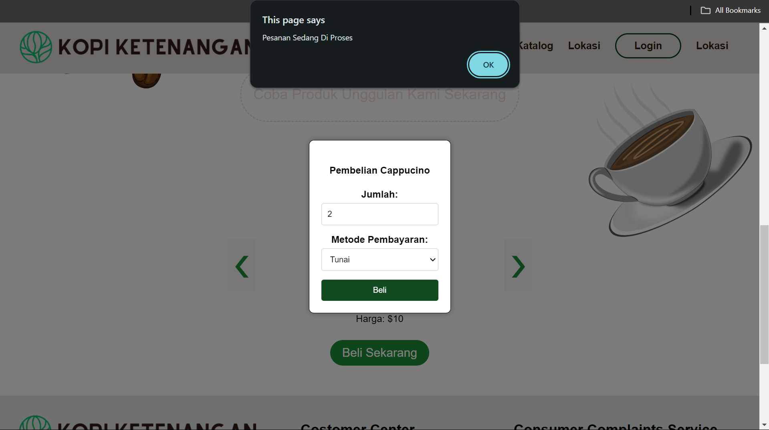

Gambar 4.1 Tampilan PopUp Index.html

Analisa :

Script di atas adalah contoh implementasi sederhana dari fitur popup dan event yang muncul saat tombol "beli" ditekan. Saat tombol tersebut ditekan, fungsi beli() akan dipanggil, yang mengambil nilai dari input dengan id "popupBtn" dan menampilkannya sebagai judul di dalam popup. Popup tersebut kemudian ditampilkan bersamaan dengan overlay yang menghalangi interaksi dengan konten di belakangnya. Selain itu, terdapat event listener pada tombol "beli" yang memunculkan alert "Pesanan Sedang Di Proses" saat tombol tersebut ditekan. Ini adalah contoh penggunaan event listener untuk menanggapi interaksi pengguna dengan tombol. Keseluruhan script ini menyediakan pengalaman interaktif yang memungkinkan pengguna untuk memicu aksi beli dan memberikan umpan balik visual melalui popup serta alert.

1. jeniskopi.html

Source code HTML:

|  |
| --- |
| <!DOCTYPE html>  <html lang="en">  <head>  <meta charset="UTF-8" />  <link rel="icon" href="assets/icon.png" />  <link rel="stylesheet" href="css/adminkopi.css" />  <!-- Boxicons CDN Link -->  <link href="https://unpkg.com/boxicons@2.0.7/css/boxicons.min.css" rel="stylesheet" />  <meta name="viewport" content="width=device-width, initial-scale=1.0" />  <title>User</title>  </head>  <body>  <!-- Popup Form -->  <div id="popup" class="popup">  <span class="close" onclick="closePopup()">&times;</span>  <form id="dataForm">  <label for="kopi">Jenis Kopi:</label>  <input type="text" id="kopi" name="kopi" required>    <label for="harga">Harga:</label>  <input type="number" id="harga" name="harga" required>    <input type="submit" value="Simpan">  </form>  </div>  <!-- Overlay -->  <div id="overlay" class="overlay"></div>  <div class="sidebar">  <div class="logo-details">  <i class="bx bx-category"></i>  <span class="logo_name">Kopi Ketenangan</span>  </div>  <ul class="nav-links">  <li>  <a href="#" class="active">  <i class="bx bx-grid-alt"></i>  <span class="links_name">Dashboard</span>  </a>  </li>  <li>  <a href="jeniskopi.html">  <i class="bx bx-box"></i>  <span class="links_name">Jenis Kopi </span>  </a>    </li>  <li>  <a href="transaksi.html">  <i class="bx bx-list-ul"></i>  <span class="links_name">Transaksi</span>  </a>    </li>  <li>  <a href="#">  <i class="bx bx-log-out"></i>  <span class="links_name">Log out</span>  </a>  </li>  </ul>  </div>  <section class="home-section">  <nav>  <div class="sidebar-button">  <i class="bx bx-menu sidebarBtn"></i>  </div>  <div class="profile-details">  <span class="admin_name"> Kopi Ketenangan</span>  </div>  </nav>  <div class="home-content">  <h3>Jenis Kopi </h3>  <button type="button" class="btn btn-tambah" onclick="togglePopup()">Add Data</button>  <table class="table-data">  <thead>  <tr>  <th style="width: 20%">Jenis Kopi</th>  <th style="width: 20%">Harga/pcs</th>  <th>Action</th>  </tr>  </thead>  <tbody id="tableBody">  <!-- Data dari local storage akan dimasukkan di sini -->  </tbody>  </table>  </div>  </section>  <script src="jeniskopi.js"></script>  </body>  </html> |

Source Code CSS :

|  |
| --- |
| @import url("https://fonts.googleapis.com/css2?family=Poppins:wght@200;300;400;500;600;700&display=swap");  * {  margin: 0;  padding: 0;  box-sizing: border-box;  font-family: "Poppins", sans-serif;  }  /* sidebar */  .sidebar {  position: fixed;  height: 100%;  width: 240px;  background: rgb(125, 50, 0);  transition: all 0.5s ease;  }  .sidebar.active {  width: 60px;  }  .sidebar .logo-details {  height: 80px;  display: flex;  align-items: center;  }  .sidebar .logo-details i {  font-size: 28px;  font-weight: 500;  color: #fff;  min-width: 60px;  text-align: center;  }  .sidebar .logo-details .logo_name {  color: #fff;  font-size: 24px;  font-weight: 500;  }  .sidebar .nav-links {  margin-top: 10px;  }  .sidebar .nav-links li {  position: relative;  list-style: none;  height: 50px;  }  .sidebar .nav-links li a {  height: 100%;  width: 100%;  display: flex;  align-items: center;  text-decoration: none;  transition: all 0.4s ease;  }  .sidebar .nav-links li a.active {  background: rgb(143, 91, 49);  }  .sidebar .nav-links li a:hover {  background: rgb(143, 91, 49);  }  .sidebar .nav-links li i {  min-width: 60px;  text-align: center;  font-size: 18px;  color: #fff;  }  .sidebar .nav-links li a .links_name {  color: #fff;  font-size: 15px;  font-weight: 400;  white-space: nowrap;  }  /* main content */  .home-section {  position: relative;  background: #f5f5f5;  min-height: 100vh;  width: calc(100% - 240px);  left: 240px;  transition: all 0.5s ease;  }  .sidebar.active ~ .home-section {  width: calc(100% - 60px);  left: 60px;  }  .home-section nav {  display: flex;  justify-content: space-between;  height: 80px;  background: #fff;  display: flex;  align-items: center;  position: fixed;  width: calc(100% - 240px);  left: 240px;  z-index: 100;  padding: 0 20px;  box-shadow: 0 1px 1px rgba(0, 0, 0, 0.1);  transition: all 0.5s ease;  }  .sidebar.active ~ .home-section nav {  left: 60px;  width: calc(100% - 60px);  }  .home-section nav .sidebar-button {  display: flex;  align-items: center;  font-size: 24px;  font-weight: 500;  }  nav .sidebar-button i {  font-size: 35px;  margin-right: 10px;  }  .home-section nav .profile-details {  display: flex;  align-items: center;  justify-content: center;  background: #f5f6fa;  border: 2px solid #efeef1;  border-radius: 6px;  height: 50px;  min-width: 190px;  }  nav .profile-details .admin_name {  font-size: 15px;  font-weight: 500;  color: #333;  white-space: nowrap;  }  .home-section .home-content {  position: relative;  padding-top: 104px;  padding-left: 20px;  padding-right: 20px;  }  .btn {  background-color: rgb(125, 50, 0);  color: white;  padding: 10px 20px;  border: none;  border-radius: 5px;  cursor: pointer;  }  .btn a {  text-decoration: none;  color: white;  }  .btn-tambah {  margin: 10px 0;  }  .btn-simpan {  width: 100%;  }  .btn:hover {  background-color: rgb(181, 119, 77);  }  .table-data {  text-align: center;  border-collapse: collapse;  width: 100%;  }  th,  td {  border: 1px solid black;  padding: 5px 20px;  }  .form-login {  display: flex;  flex-direction: column;  align-items: center;  background-color: white;  padding: 30px;  margin: 10px auto;  border-radius: 10px;  }  .input {  width: 100%;  margin: 10px 0;  padding: 10px;  border-radius: 10px;  border: 1px solid rgb(148, 148, 148);  }  /* Responsive Media Query */  @media (max-width: 1240px) {  .sidebar {  width: 60px;  }  .sidebar.active {  width: 220px;  }  .home-section {  width: calc(100% - 60px);  left: 60px;  }  .sidebar.active ~ .home-section {  /* width: calc(100% - 220px); */  overflow: hidden;  left: 220px;  }  .home-section nav {  width: calc(100% - 60px);  left: 60px;  }  .sidebar.active ~ .home-section nav {  width: calc(100% - 220px);  left: 220px;  }  }  @media (max-width: 700px) {  nav .profile-details {  display: none !important;  }  .home-section nav .profile-details {  height: 50px;  min-width: 40px;  }  }  @media (max-width: 550px) {  .profile-details {  display: none !important;  }  }  @media (max-width: 400px) {  .sidebar {  width: 0;  }  .sidebar.active {  width: 60px;  }  .home-section {  width: 100%;  left: 0;  }  .sidebar.active ~ .home-section {  left: 60px;  width: calc(100% - 60px);  }  .home-section nav {  width: 100%;  left: 0;  }  .sidebar.active ~ .home-section nav {  left: 60px;  width: calc(100% - 60px);  }  }  /* Styling untuk popup */  .popup {  display: none;  position: fixed;  top: 50%;  left: 50%;  transform: translate(-50%, -50%);  background-color: #ffffff;  padding: 20px;  border-radius: 20px;  border: 1px solid #000000;  box-shadow: 0 0 10px rgba(0, 0, 0, 0.3);  z-index: 9999;  width: 300px; /* Lebar popup */  }  /* Styling untuk overlay */  .overlay {  display: none;  position: fixed;  top: 0;  left: 0;  width: 100%;  height: 100%;  background-color: rgba(0, 0, 0, 0.5);  z-index: 9998;  }  /* Styling untuk tombol close */  .close {  position: absolute;  top: 10px;  right: 10px;  cursor: pointer;  }  .close {  position: absolute;  top: 10px;  right: 10px;  cursor: pointer;  font-size: 20px;  color: #000000;  }  /* Styling untuk form di dalam popup */  #dataForm {  margin-top: 20px;  }  #dataForm label {  display: block;  margin-bottom: 5px;  }  #dataForm input[type="text"],  #dataForm input[type="number"] {  width: calc(100% - 12px); /* Lebar input minus padding */  padding: 6px;  margin-bottom: 10px;  border: 1px solid #ccc;  border-radius: 4px;  box-sizing: border-box;  }  #dataForm input[type="submit"] {  background-color: #4CAF50;  color: white;  padding: 10px 20px;  border: none;  border-radius: 4px;  cursor: pointer;  width: 100%;  }  #dataForm input[type="submit"]:hover {  background-color: #45a049;  } |

Source Code Java Script :

|  |
| --- |
| let sidebar = document.querySelector(".sidebar");  let sidebarBtn = document.querySelector(".sidebarBtn");  sidebarBtn.onclick = function () {  sidebar.classList.toggle("active");  if (sidebar.classList.contains("active")) {  sidebarBtn.classList.replace("bx-menu", "bx-menu-alt-right");  } else sidebarBtn.classList.replace("bx-menu-alt-right", "bx-menu");  };    const dataForm = document.getElementById('dataForm');  const popup = document.getElementById('popup');  const overlay = document.getElementById('overlay');  function togglePopup() {  popup.style.display = 'block';  overlay.style.display = 'block';  }  dataForm.addEventListener('submit', function(event) {  const key = "dataKopi";  event.preventDefault();    const kopi = document.getElementById('kopi').value;  const harga = document.getElementById('harga').value;  // Membuat objek untuk data yang akan disimpan di local storage  const newData = {  kopi: kopi,  harga: harga  };  // Ambil data yang telah disimpan sebelumnya  let storedData = JSON.parse(localStorage.getItem(key)) || [];  // Tambahkan data baru ke dalam array data yang telah ada  storedData.push(newData);  // Simpan kembali data ke local storage  localStorage.setItem(key, JSON.stringify(storedData));  // Tampilkan data terbaru di tabel  displayData();  // Tampilkan pesan sukses  alert('Data berhasil disimpan di Local Storage.');  // Tutup popup  closePopup();  // Reset nilai input  document.getElementById('kopi').value = '';  document.getElementById('harga').value = '';  });  function displayData() {  const tableBody = document.getElementById('tableBody');  tableBody.innerHTML = '';  const storedData = JSON.parse(localStorage.getItem('dataKopi'));  if (storedData) {  storedData.forEach(function(data) {  const row = document.createElement('tr');  const jenisKopiCell = document.createElement('td');  const hargaCell = document.createElement('td');  const actionCell = document.createElement('td');  jenisKopiCell.textContent = data.kopi;  hargaCell.textContent = data.harga;  actionCell.innerHTML = '<a href="#">Edit</a> | <a href="#">Hapus</a>';  row.appendChild(jenisKopiCell);  row.appendChild(hargaCell);  row.appendChild(actionCell);  tableBody.appendChild(row);  });  }  }  function closePopup() {  popup.style.display = 'none';  overlay.style.display = 'none';  }  // Panggil fungsi displayData saat halaman dimuat untuk pertama kali  displayData(); |

Hasil Tampilan :

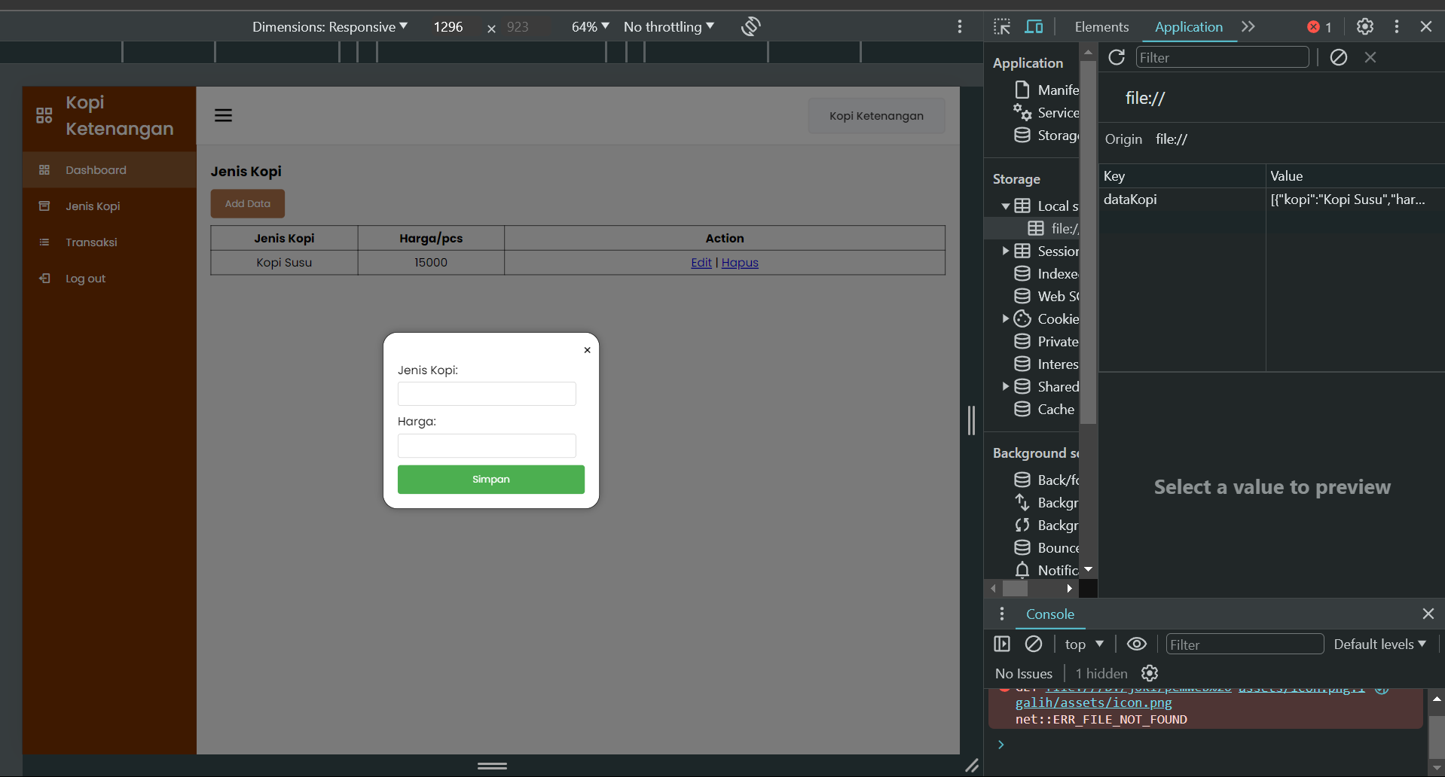

Gambar 4.1 Tampilan PopUp Index.html

Analisa :

Script yang diberikan memiliki dua fungsi utama: pertama, ia memungkinkan pengguna untuk memasukkan data jenis kopi dan harga melalui sebuah form popup, dan kedua, ia menampilkan data yang telah dimasukkan sebelumnya dalam sebuah tabel HTML. Saat pengguna mengirimkan data melalui form, data tersebut disimpan dalam local storage menggunakan kunci yang telah ditentukan. Setelah data disimpan, tabel akan diperbarui secara otomatis untuk menampilkan data terbaru. Dengan demikian, script ini menyediakan sebuah mekanisme sederhana untuk pengelolaan data kopi yang mudah digunakan oleh pengguna.

Top of Form